**Microsoft Access**

**Session 4.4: Overview**

This document is a quick reference guide for reviewing the techniques in the laboratory.

For these exercises, download the files:

“Business Analytics – Week 4 Instructions.doc”

“Business Analytics – Week 4 Excel 2013.xls”

“Business Analytics – Week 4 Orders NoRelationships Database.acc”

“Business Analytics – Week 4 Orders Relationships Database.acc”

**Background**

In Excel, we could have multiple spreadsheets within a workbook. However, these spreadsheets did not necessarily relate to each other. In Microsoft Access, we will use a similar concept, but it’s called tables. A table is like a spreadsheet. The key difference is that multiple tables can relate to each other and be combined to form calculations, summaries, queries and reports. When tables are combined, we say they are joined. Tables can be joined based on relationships. This tutorial explores tables, relationships, and their uses in retrieving and adding data to a database.

**Importing Data**

Generally, if you are starting from scratch, it’s easiest to build data into an Excel spreadsheet and import it into Access. Excel allows data to easily be imported from the web or entered directly. Editing and formulas can manipulate the data before you convert it to Access format.

Let’s first examine data in the Alumni tab of your spreadsheet.

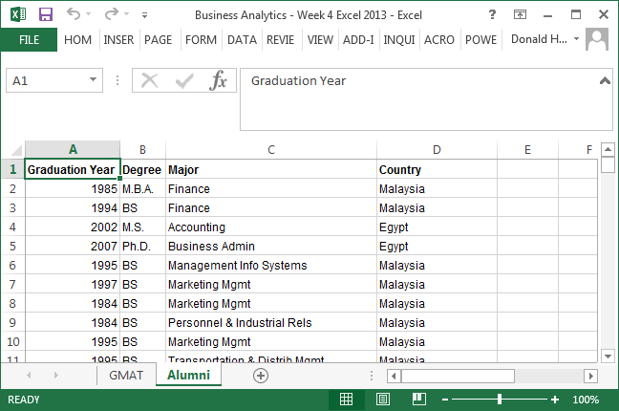

Data includes graduation year, degree, major and country for each student.

Data for GMAT test takers is shown in the GMAT tab.

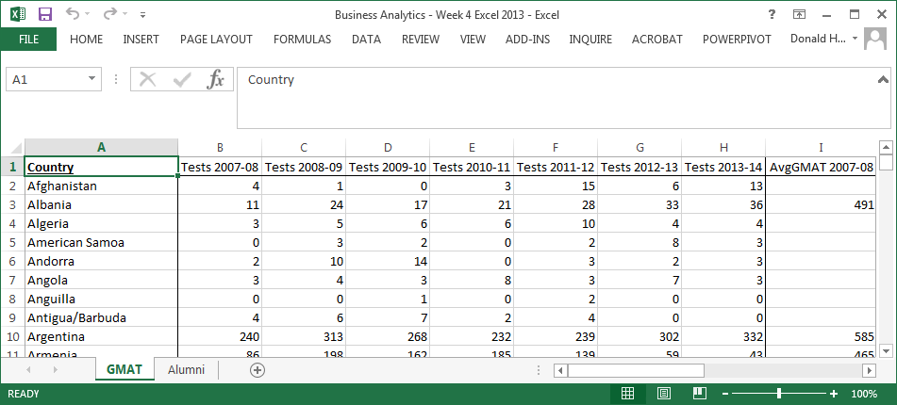

Let’s import the data from Excel to Access by using the Access Import capability.

1. Open Microsoft Access by clicking on the Start button, all Programs, Microsoft Office, Access.
2. Click on Blank Database.
3. In the File Name field, enter Recruiting, then click Create.
4. Click on the tab External Data, then Excel in the Import section.
5. Use the Browse button to find your spreadsheet, then click OK.

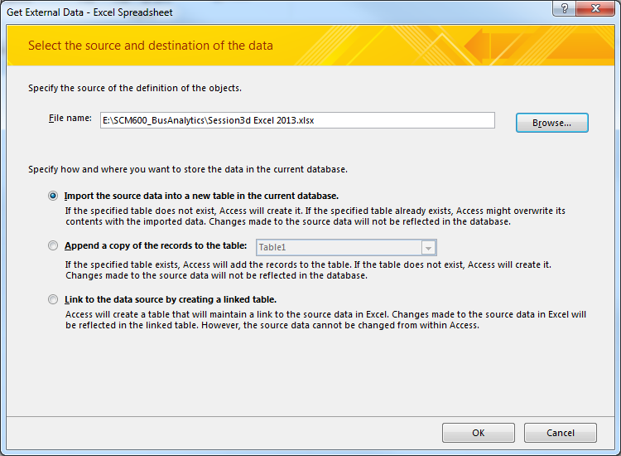

1. Select the appropriate worksheet from the workbook. In this case, use Alumni, then Next.

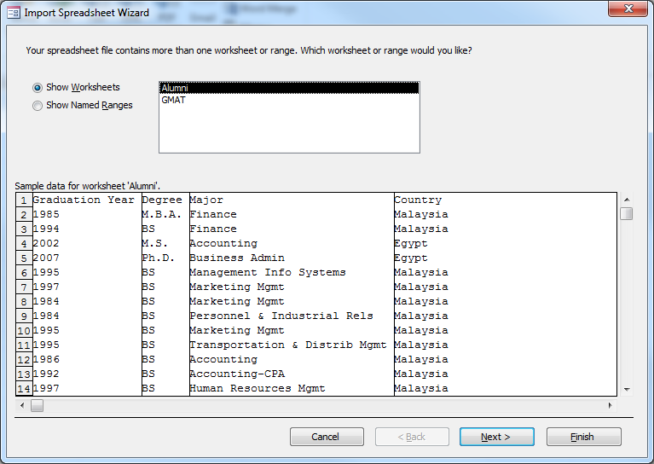

1. Access will try to detect if you have labels in the first row. Confirm and click Next.

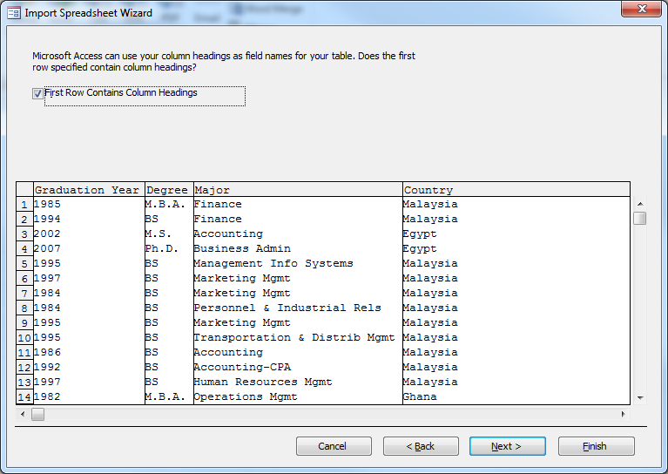

1. The next screen allows you to determine whether each column is text, numeric, etc., and set the characteristics. Access is pretty good at setting these automatically. Click Next.

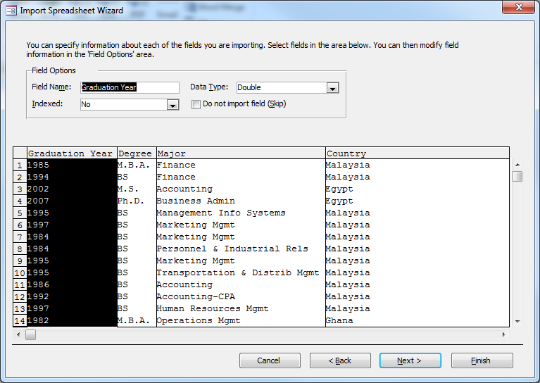

1. Next, Access allows you to add a primary key. Primary keys allow you to uniquely identify each row in a table. However, if you let Access add one, it always adds an arbitrary key that means nothing. Click on No primary key, then Next.

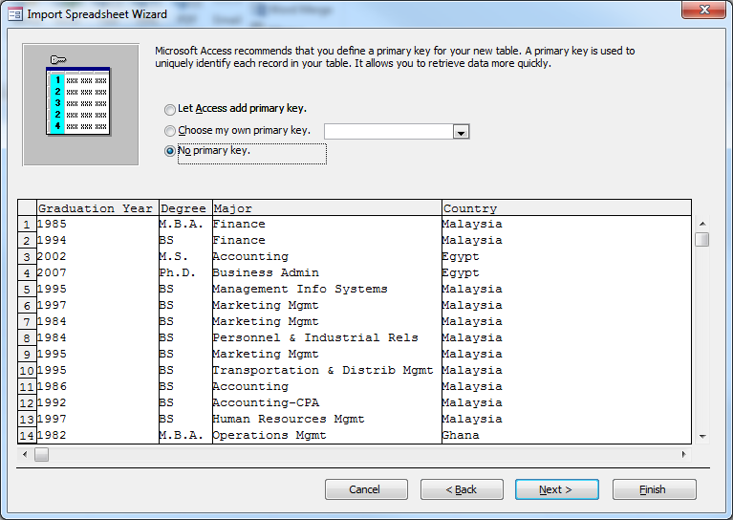

1. The last screen allows you to name the table. Let’s call it Aumni. Click Finish.

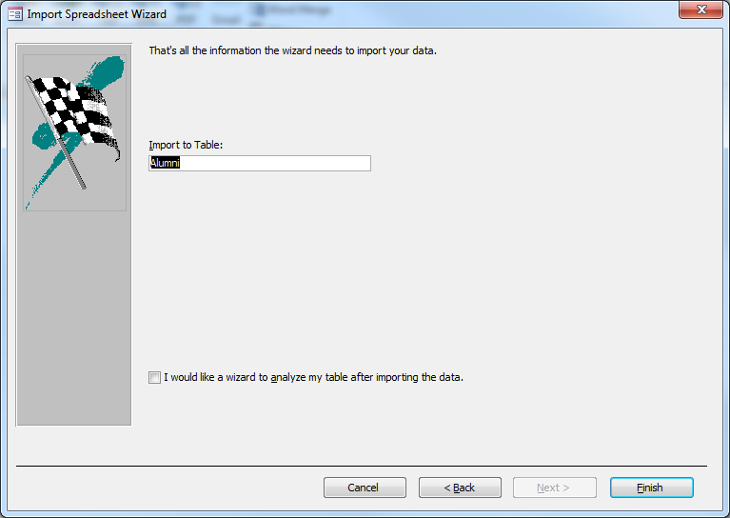

Now follow the same set of steps to add the GMAT data from your spreadsheet. Both tables should appear in your Access database.

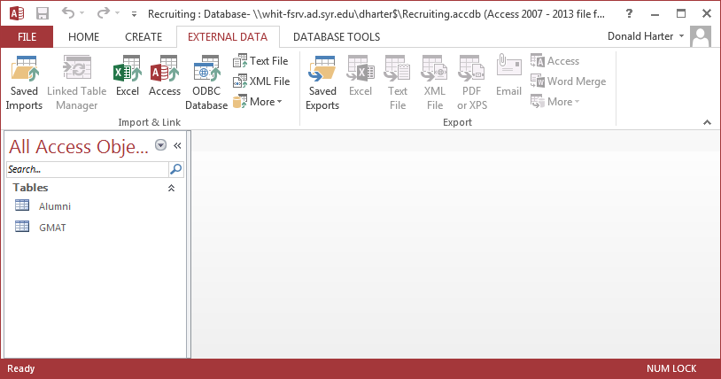

Double click on the table name Alumni to view the data.

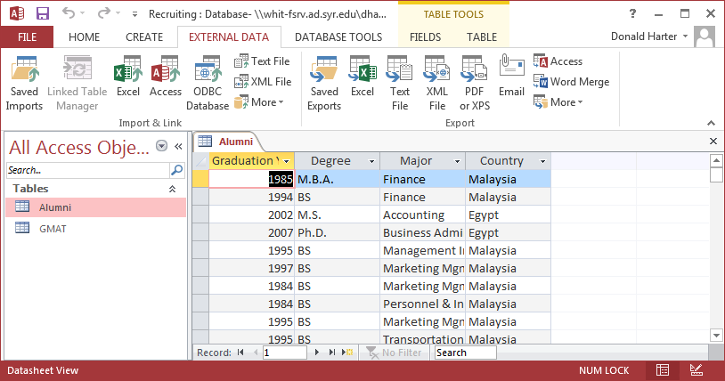

**Session 4.5: Relationships**

Relationships describe how tables relate to each other. Click on the Database Tools tab, then relationships. You should see the following pop-up.

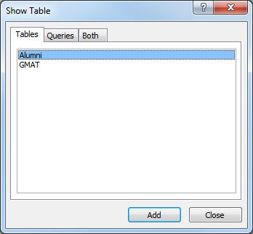

Click on Alumni, then Add. Click on GMAT, then Add. Click Close.

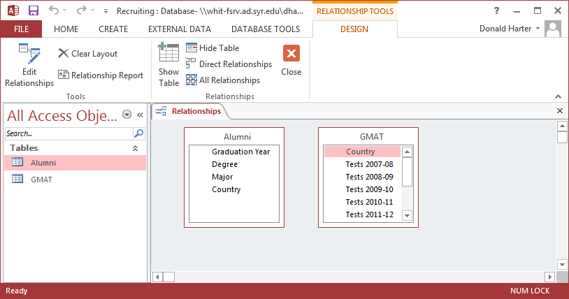

There is no relationship (yet) between these table. Click on Country in Alumni, then drag to Country in GMAT.

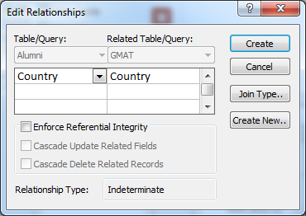

Now click Create. This “joins” the two tables using the field Country in each table.

Click on the X to the right of Relationships. When it asks if you want to save Relationships, click Yes.

**Session 4.6: Simple Queries**

When you want to retrieve specific data from a database, you can use a query. A query is like a filter in Excel, but much more powerful. It can allow you to restrict what data is displayed, sort the data, and perform calculations. However, dirty data can corrupt your queries. Let’s see how.

To create a query, click on CREATE, then Query Design.

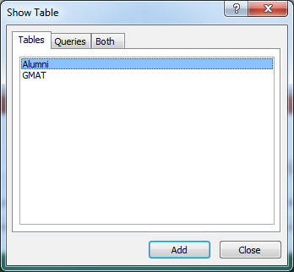

Click on Alumni, then Add; GMAT, then Add.

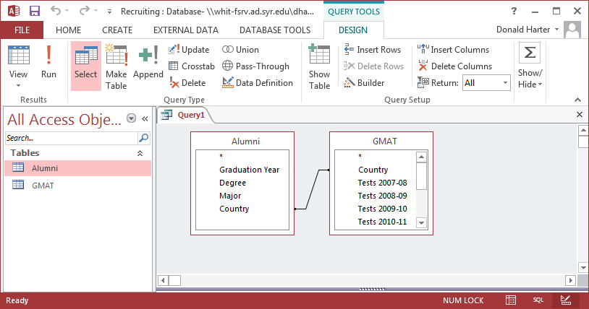

Let’s compare Countries in the Alumni table to Countries in the GMAT table.

1. In the table Alumni, double click Country.
2. In the table Alumni, double click Degree
3. In the table GMAT, double click AvgGMAT 2011-12.
4. Click Run !

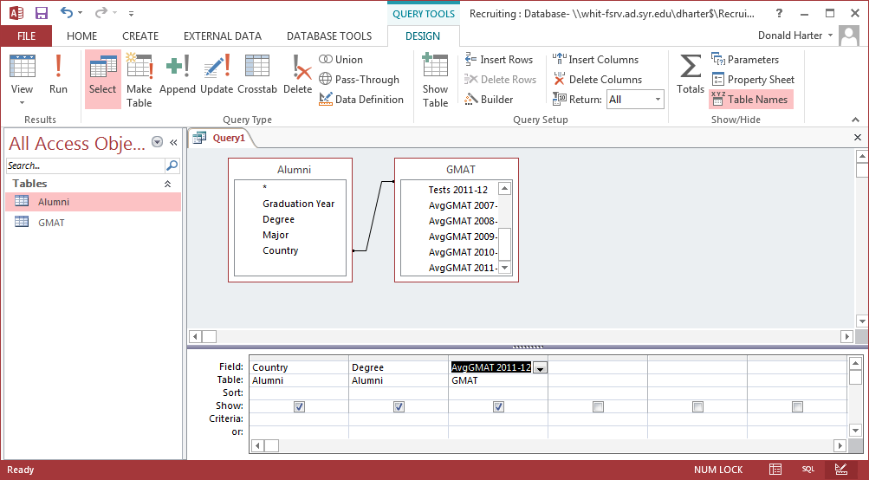

Now click Run ! in the upper right corner.

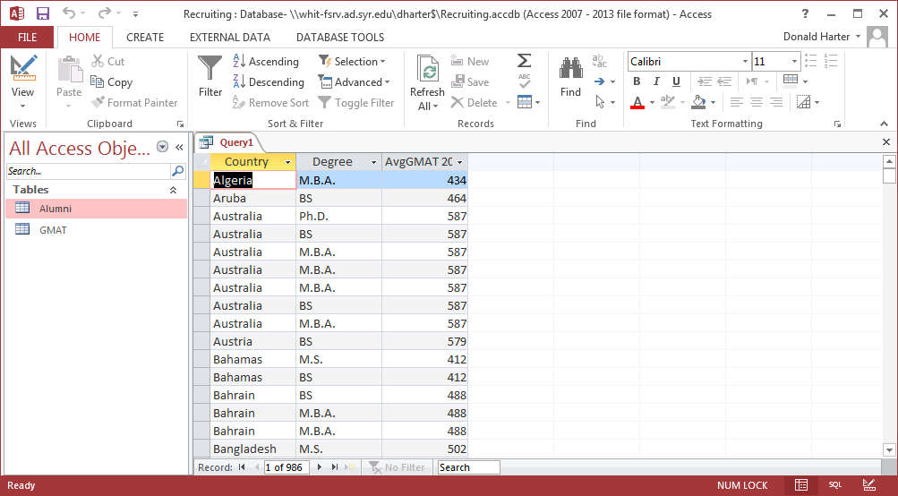

This lists each student, rather than a summary.

Click on View, Design View, to go back to the query.

Click on the Sigma (summation sign).

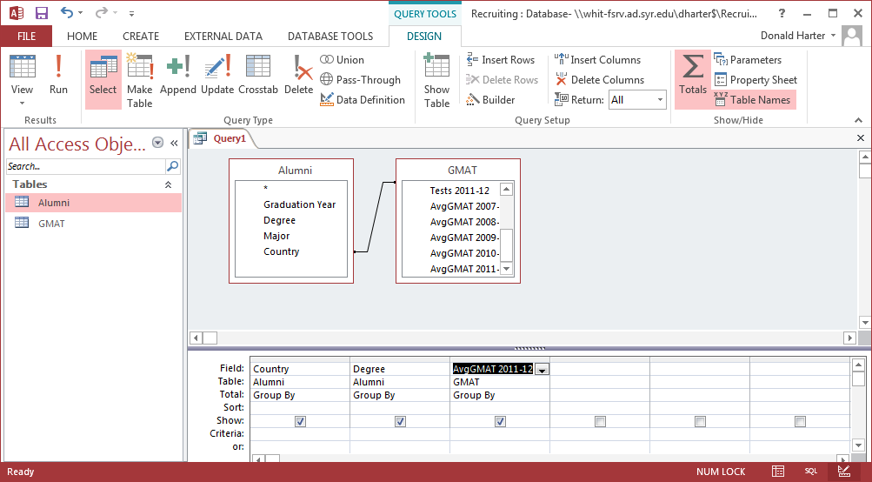

It now adds the Total line Group By. We want to Group By country, but we really want to count degrees and average the GMAT scores.

Where it says Group By under Degree, use the drop down menu to change to Count.

Where it says Group By under AvgGMAT 2011-2012, use the drop down menu to change to Average.

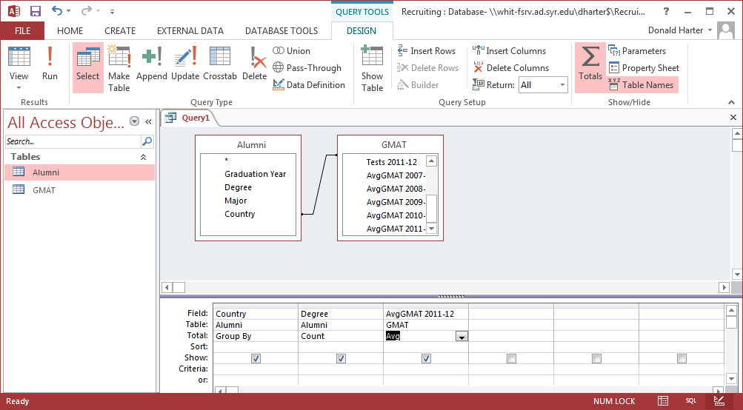

Now click Run !.

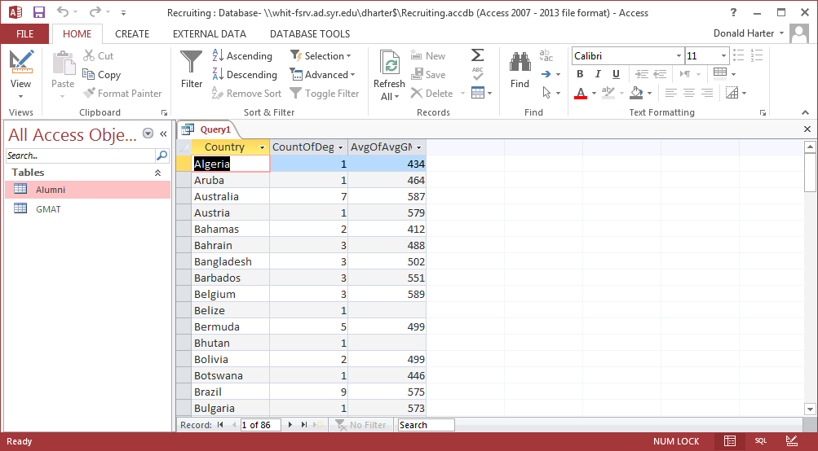

Go back to the Design and use the Sort field to change how data is sorted.

The criteria field allows you to filter results. Find the countries that have more than five alumni and average GMAT more than 500 by using >5 and >500.

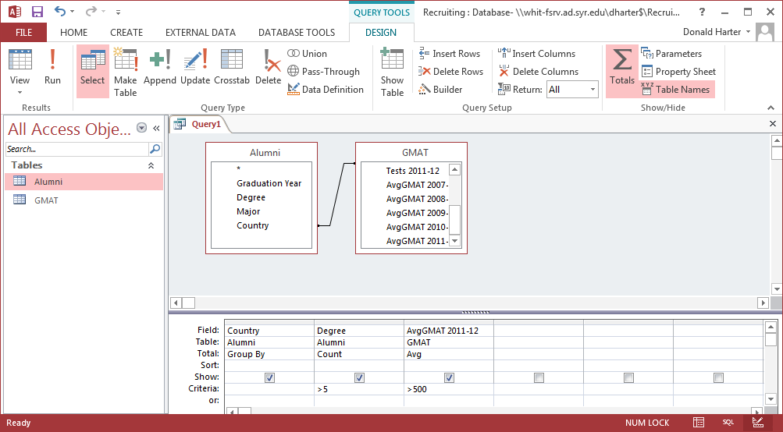

Click Run !.

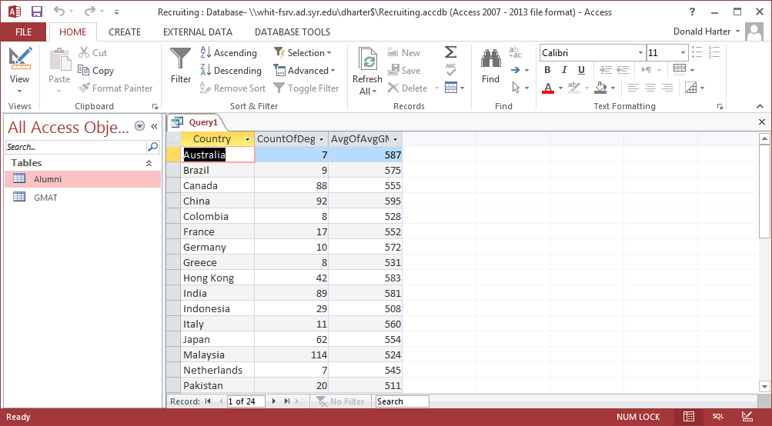

**Session 4.7: Queries & Fixing Dirty Data**

When you want to retrieve specific data from a database, you can use a query. A query is like a filter in Excel, but much more powerful. It can allow you to restrict what data is displayed, sort the data, and perform calculations. However, dirty data can corrupt your queries. Let’s see how.

To create a query, click on CREATE, then Query Design.



Click on Alumni, then Add; GMAT, then Add. Click Close.



Let’s compare Countries in the Alumni table to Countries in the GMAT table.

1. In the table Alumni, double click Country.
2. In the table GMAT, double click Country.
3. Click Run !

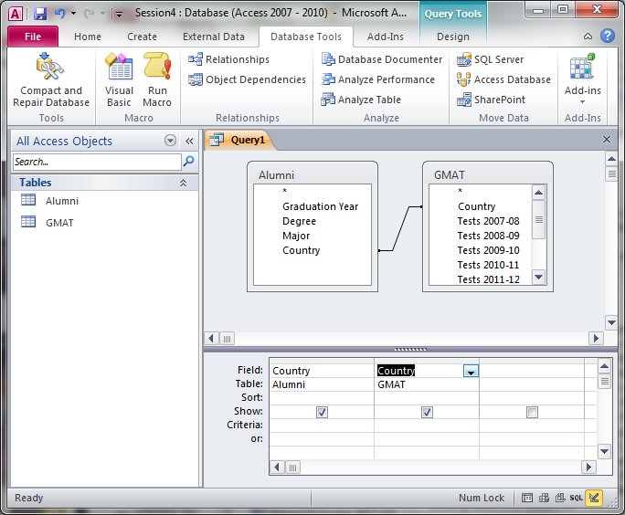

Now click Run ! in the upper left corner.

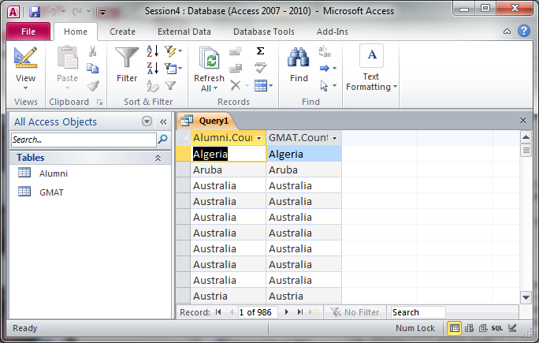

Notice that this lists duplicates of each country. To eliminate duplicates:

1. Click on View, Design View.
2. Click on the summation sign (Sigma) for Totals.
3. A Group By appears.
4. Click Run !

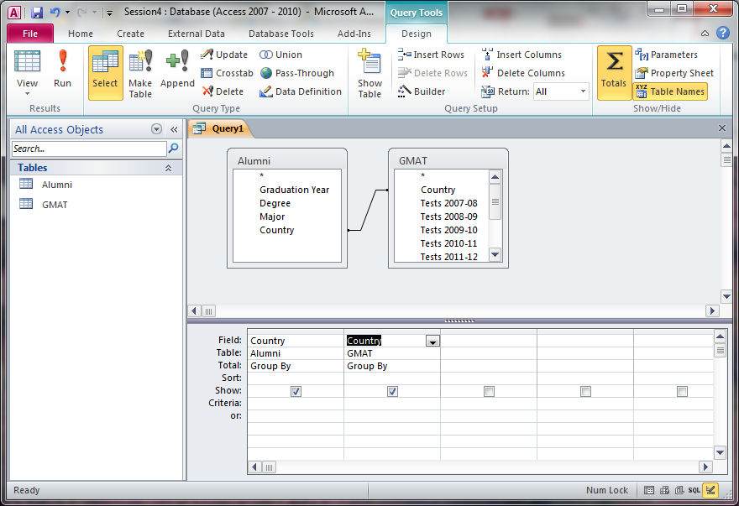

Now duplicates are eliminated.

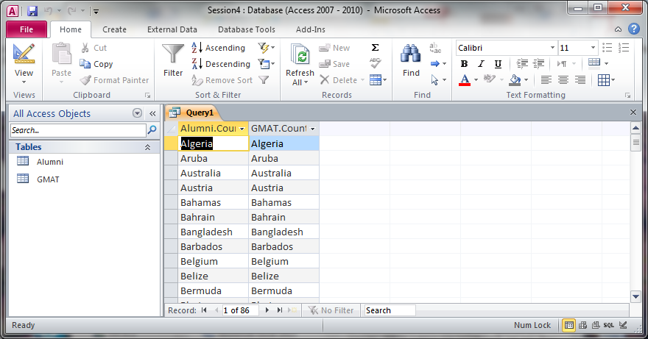

Look for Taiwan in the data. Does it appear?

Open the table for Alumni. Does Taiwan appear?

Open the table for GMAT. Does Taiwan appear?

What’s the difference?

Now, let’s allow Access to identify data discrepancies.

1. In your query, click on View, Design View.
2. Right click on the line connecting the tables.
3. Click on Join Properties
4. Change the selection to 2: Include All records from “Alumni” and only those records from “GMAT” where the joined fields are equal, then click OK.
5. Click Run !
6. Are there any entries in column 1 (Alumni.Country) that have blank entries in column 2 (GMAT.Country)? Why?

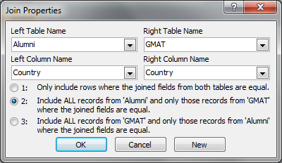

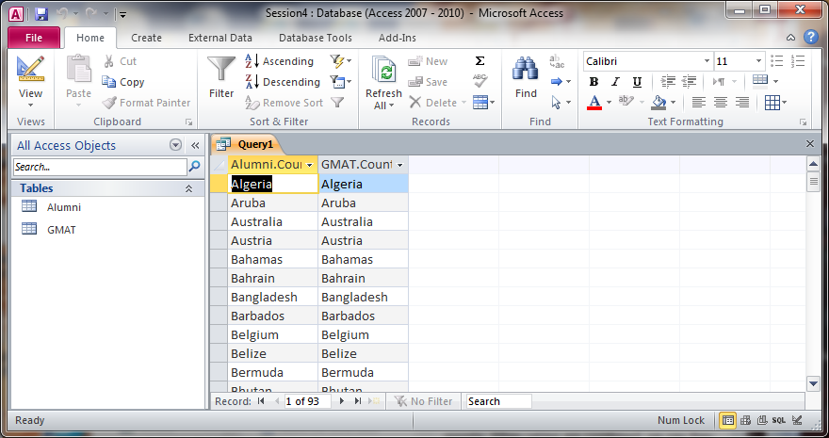

Change the relationship to selection 3. What happens?

**Session 4.8: Complex Queries**

Open the database titled Business Analytics – Week 4 Orders NoRelationships Database. We are going to create relationships.

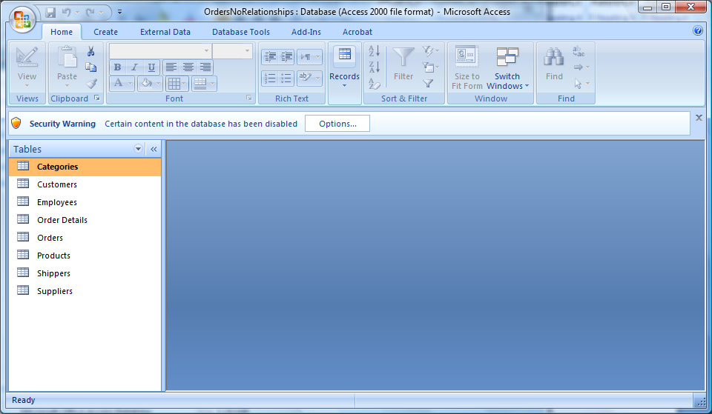

1. Click on Database Tools, Show Relationships, Show Table.

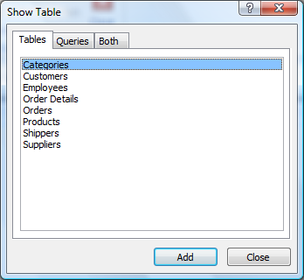

1. Click on each table, then add. When you have added all tables, click close.

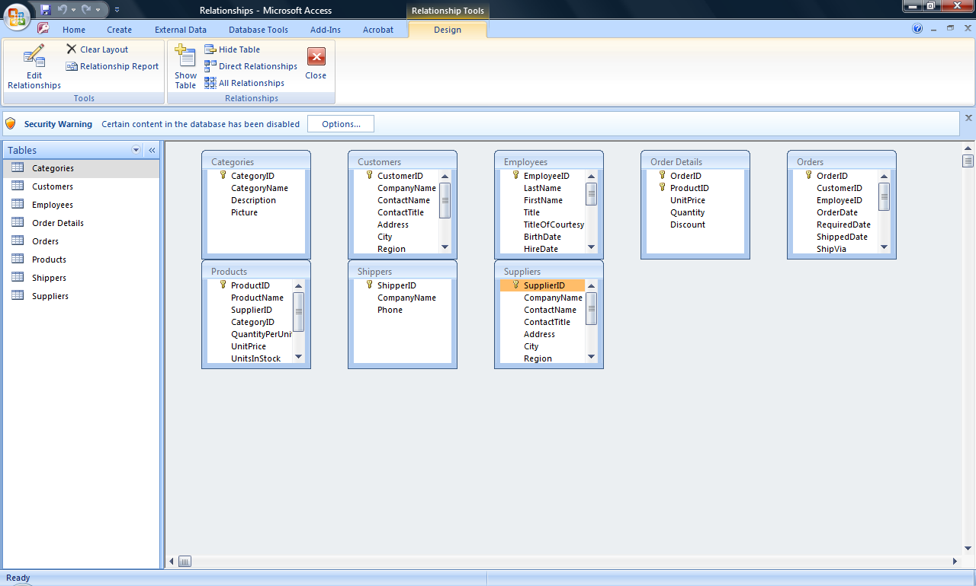

1. The key fields are identified with a picture of a key. To create relationships, drag a field to the similarly named field in another table. Drag Order ID in Orders to Order ID in Order Details.

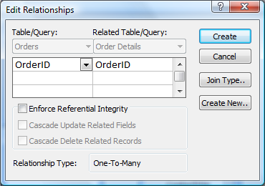

1. You should see the screen above. If you want to ensure that data in one table matches data in the other (called referential integrity), check the box. Notice that Access has determined that this relationship will be one-to-many. Click Create.
2. Similarly link the other tables. When done, you should have a picture that looks like this. Notice that I’ve rearranged the tables to clean up the lines.
3. Close the relationship box and save the new relationships.

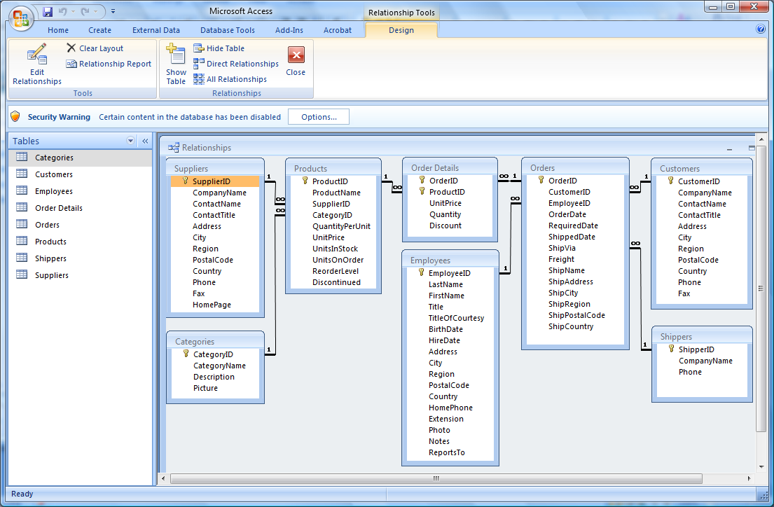

**Queries**

When you want to retrieve specific data from a database, you can use a query. A query is like a filter in Excel, but much more powerful. It can allow you to restrict what data is displayed, sort the data, and perform calculations.

For this section, use the Business Analytics – Week 4 Orders Relationships Database. Let’s recall how the tables relate by clicking on the Database Tools tab, then Relationships.

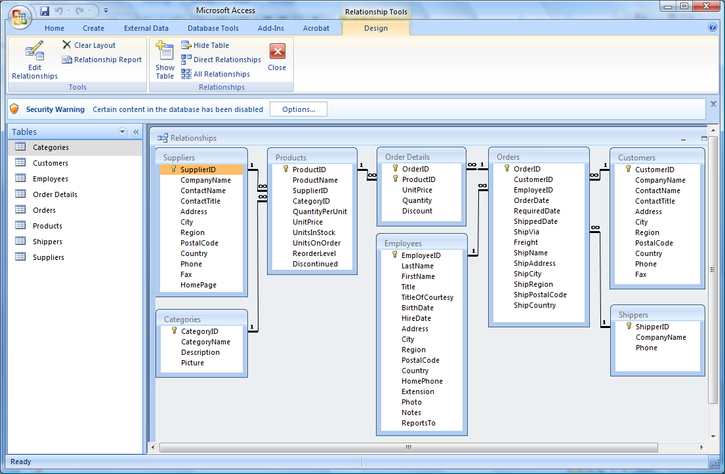

Let’s find all ProductNames that have a CategoryName of beverages. Looking at the tables in the relationship diagram, can you find ProductNames and CategoryName? What tables are they in?

1. To create a query, click on the Create tab, then Query Design.

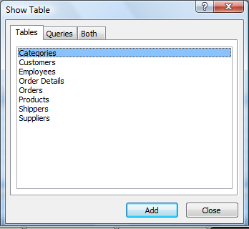

1. Since we want to use the tables Products and Categories, click on each one, then Add, then Close

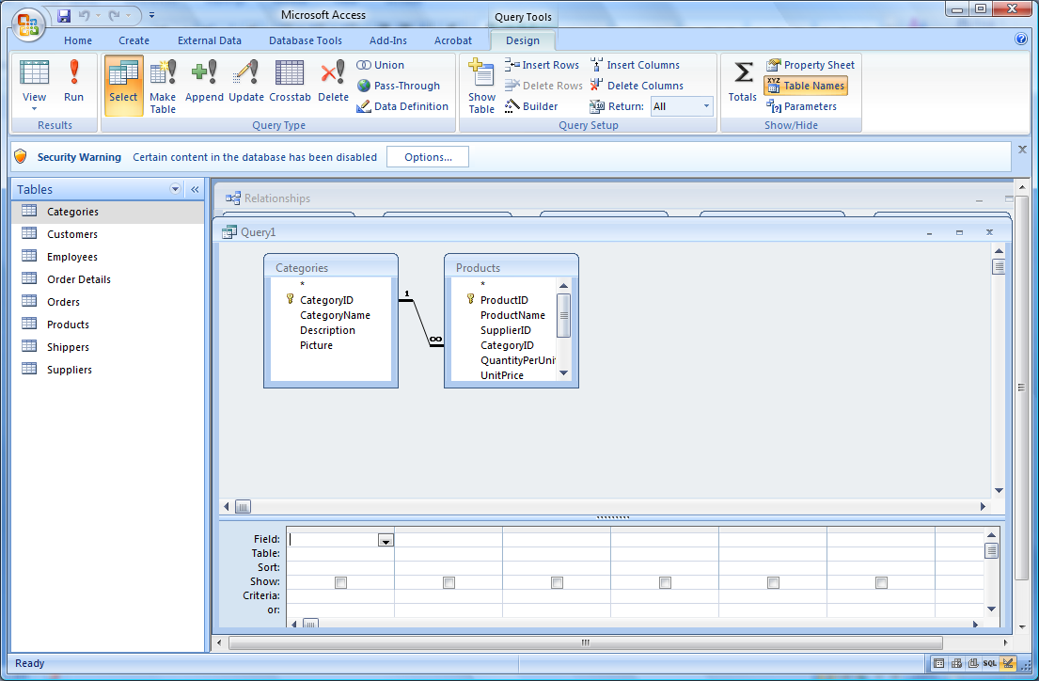

1. At the top of the screen are the two tables. At the bottom is a set of options to set up the query.
2. We want to find all the Product Names for each Category Name. First, double click on Category Name. It should appear at the bottom of the page
3. Next, double click on Product Name. It should appear next to Category Name.
4. If you want to sort the data, click on sort under Category Name, then ascending.

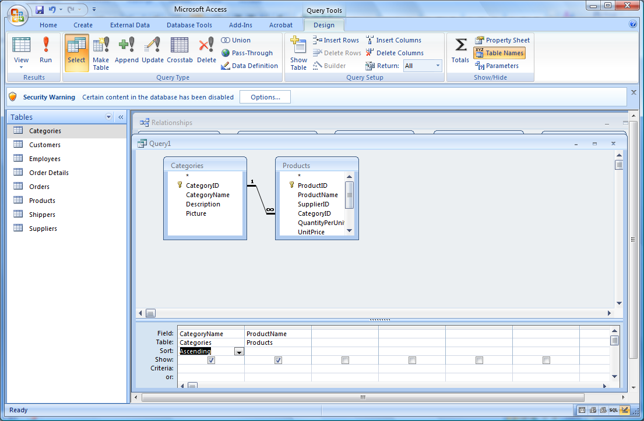

1. To run the query, click Run (see red exclamation point). You should see the following result.

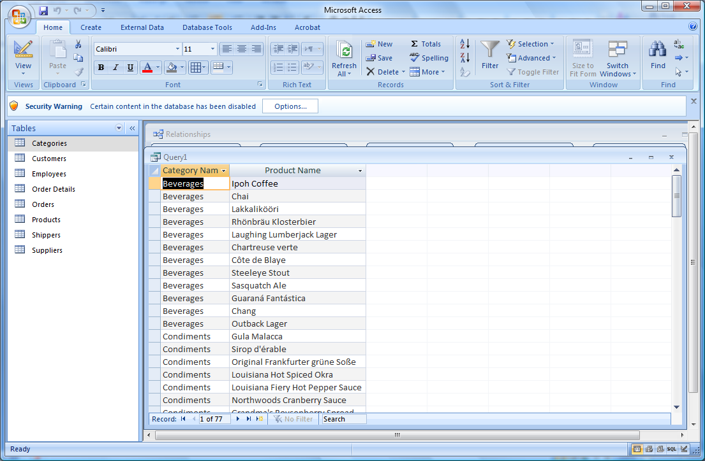

**Filtering or Using Criteria to Restrict the Output**

Just as you filtered data in Excel, you can filter data in Access. If we only want Beverages listed, use the following steps.

1. On the Home tab, click on View, Design View. This takes you back to the design of the query.
2. In the field called Criteria under Category name, enter the word Beverages. Notice that it puts quotation marks around it automatically.

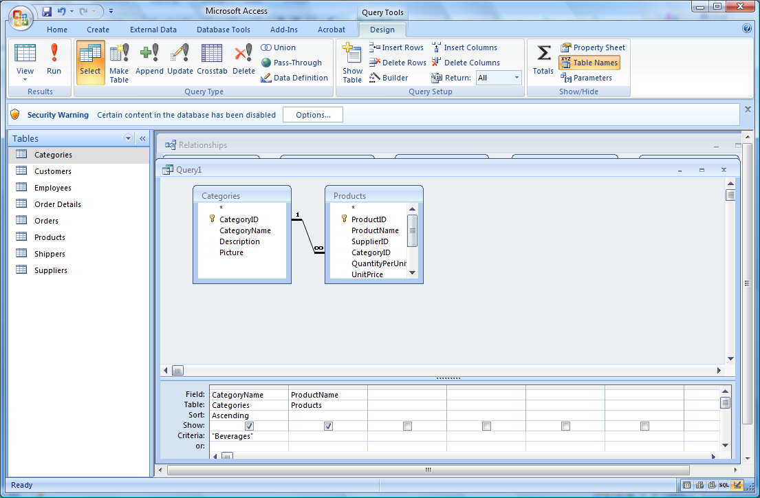

1. Run the query. Only Beverages are displayed.

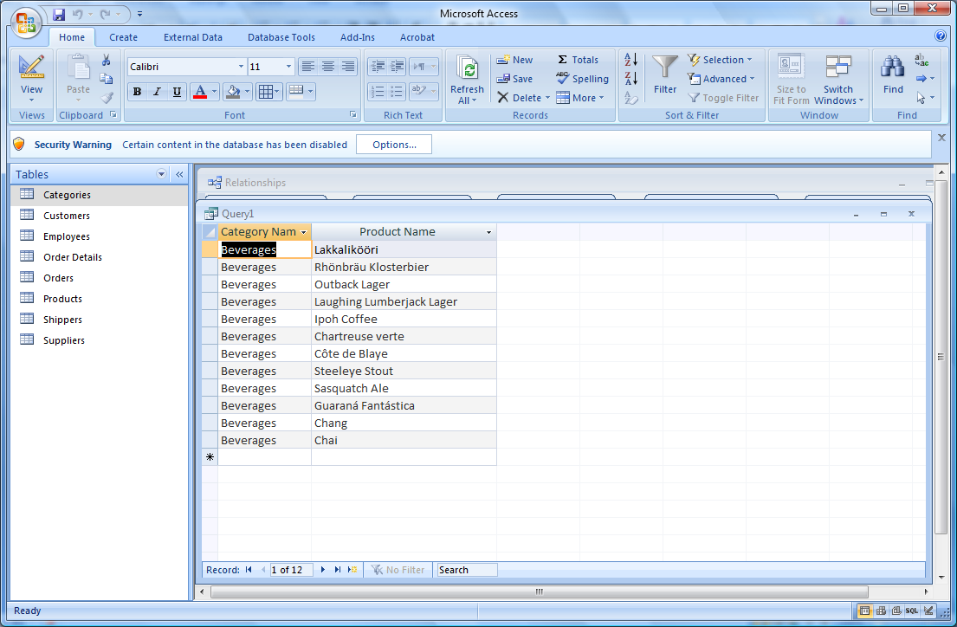

**Queries with Two or More Criteria Using “And”**

You can also run queries where multiple conditions must be true. Let’s find beverages with Unit Price greater than 10.

1. Click on the Home tab, View, Design View.
2. Since we don’t have Unit Price in the query screen, add it by double clicking on Unit Price in Products.
3. In the criteria for Unit Price, enter >10

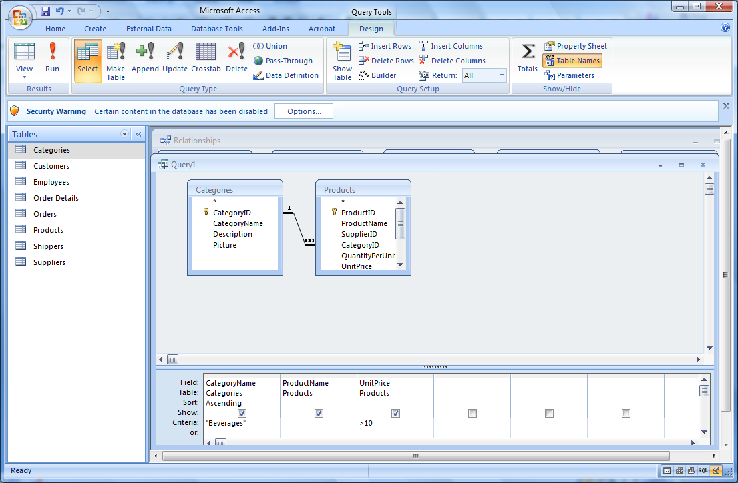

1. Run the query

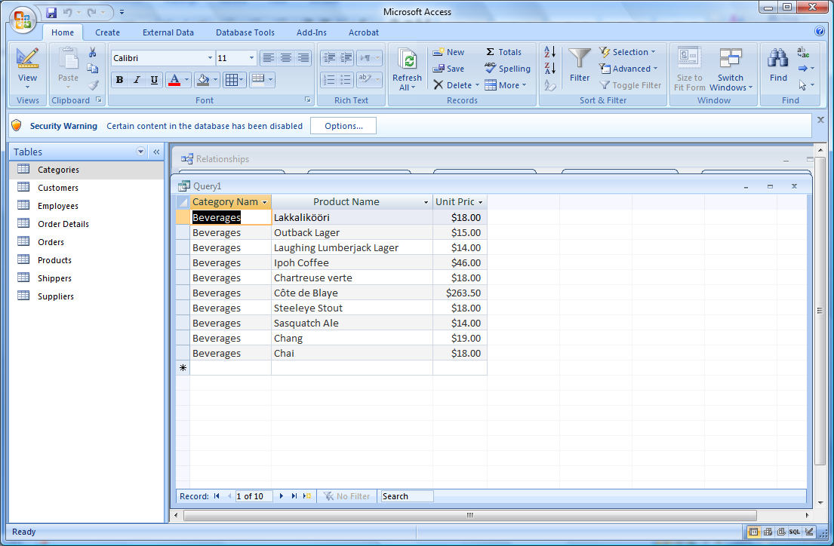

**Query with an “Or” Condition – within one field**

You can also have an OR condition. For example, if we want Beverages or Condiments, we can put “Beverages” OR “Condiments” in the criteria field for Category Name.

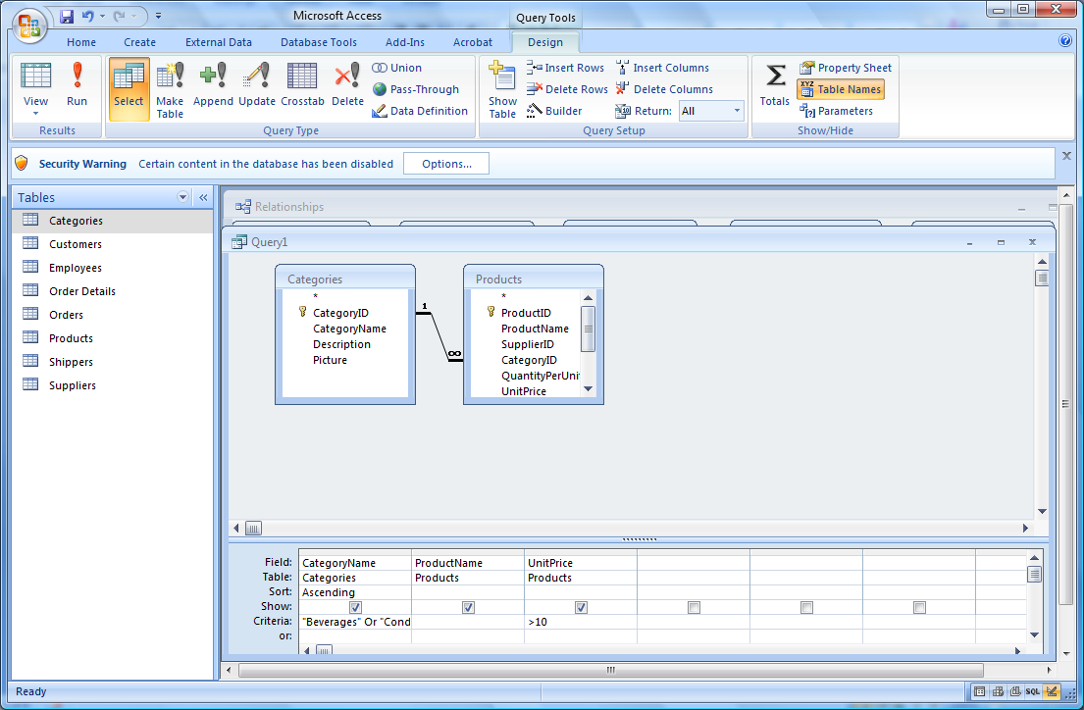

The result of running the query is shown below.

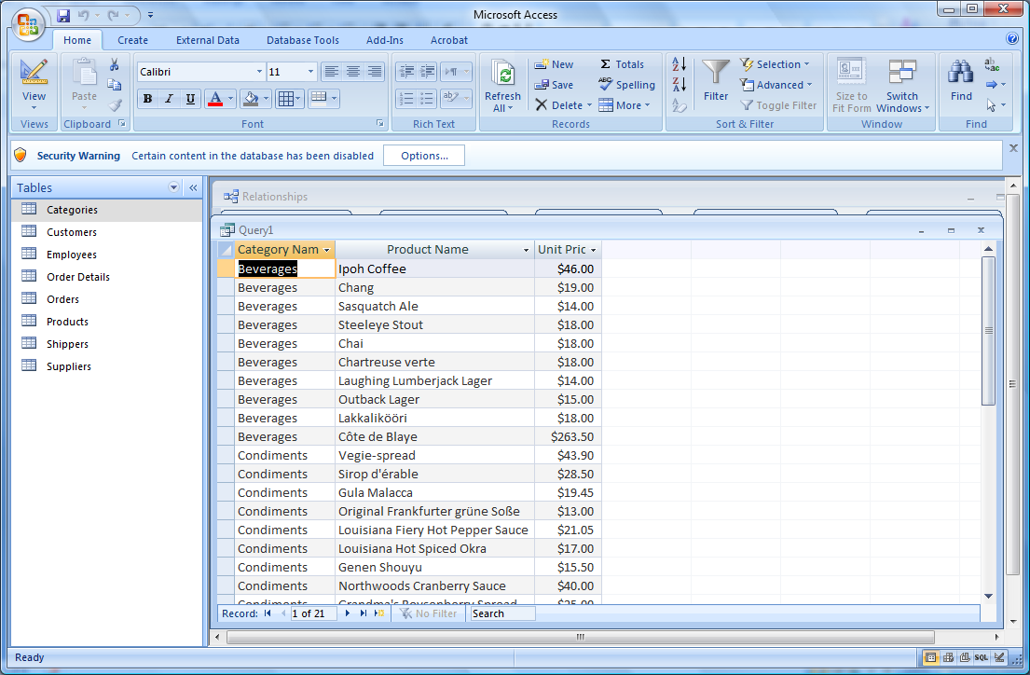

**Query with an “Or” Condition – between fields**

You can also use multiple criteria rows for an OR condition instead of cramming everything into one cell. Let’s use multiple lines for the previous query. Note that if we also want >10, that >10 has to be on both lines.

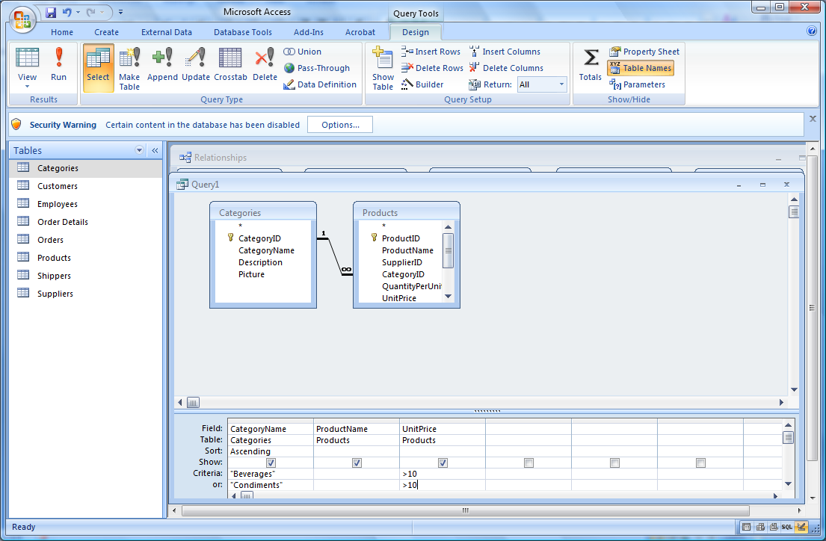

**Calculations**

The calculation of sums, averages, counts, minimum, maximum can also be performed in a query. Let’s sum the total number of units in stock using our current criteria.

1. First, add UnitsInStock from the Products table
2. Click on the Design tab, then click on the summation symbol ∑
3. A total line should appear, where it says group by for each variable.
4. We want to have groupings of Categories and Products, but not UnitPrice. For UnitPrice, use the down arrow on GroupBy and change it to Where. A Where clause is used to filter data; you never group on a where.
5. We don’t want to group on UnitsInStock, but we want to sum the total instead. Change GroupBy for UnitsInStock to Sum. You should have the following.

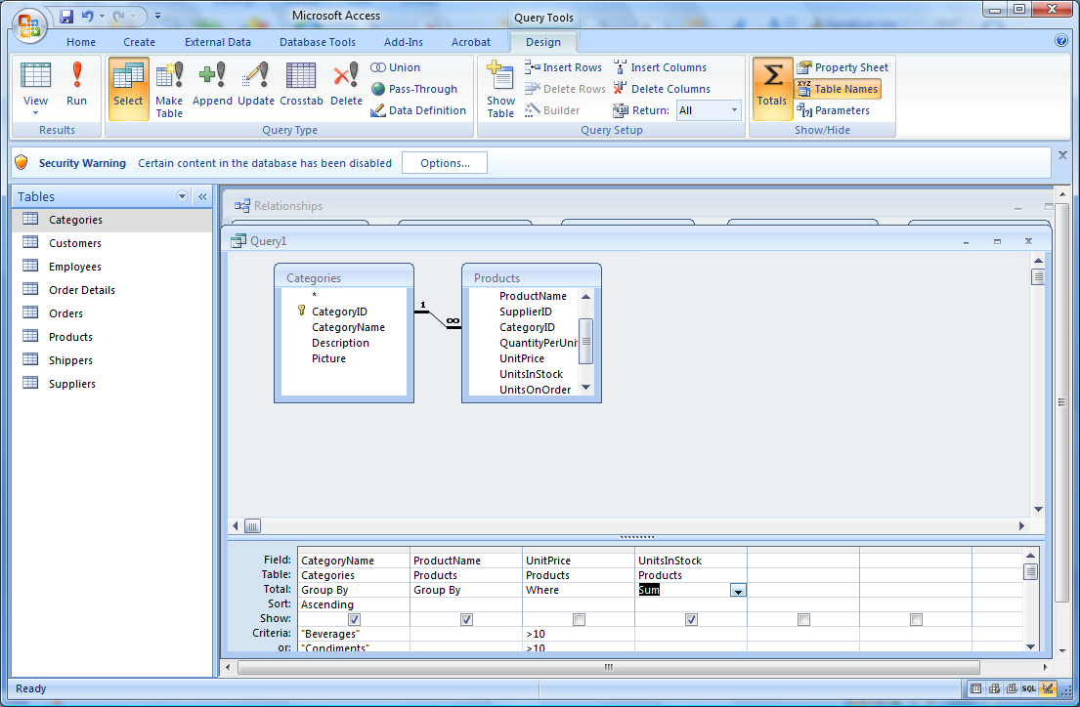

1. Now run the query.

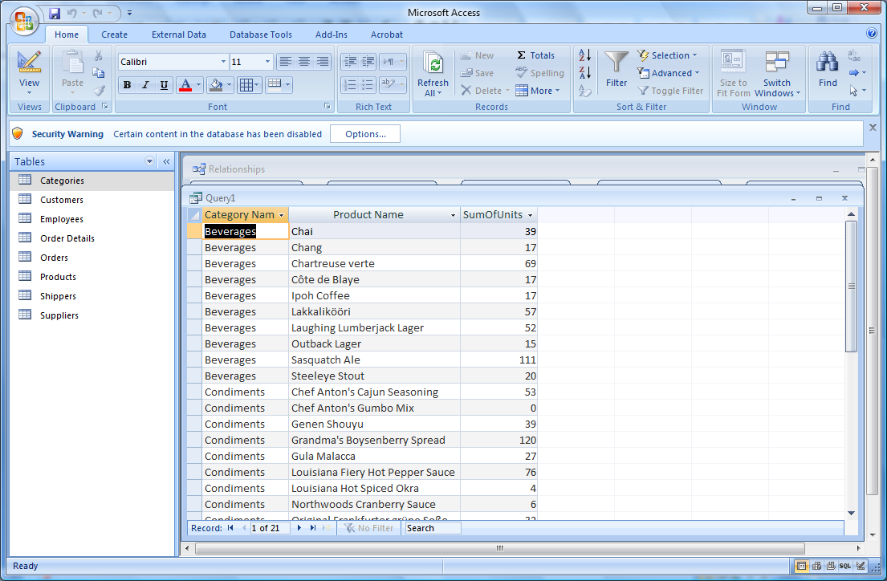

**Saving a Query**

To save a query, click on the Microsoft button in the upper left of your screen, click Save, then enter the name of your query. Click OK.

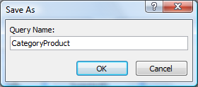

You can retrieve old queries by clicking on the down arrow next to the word Tables, then selecting Queries.

